

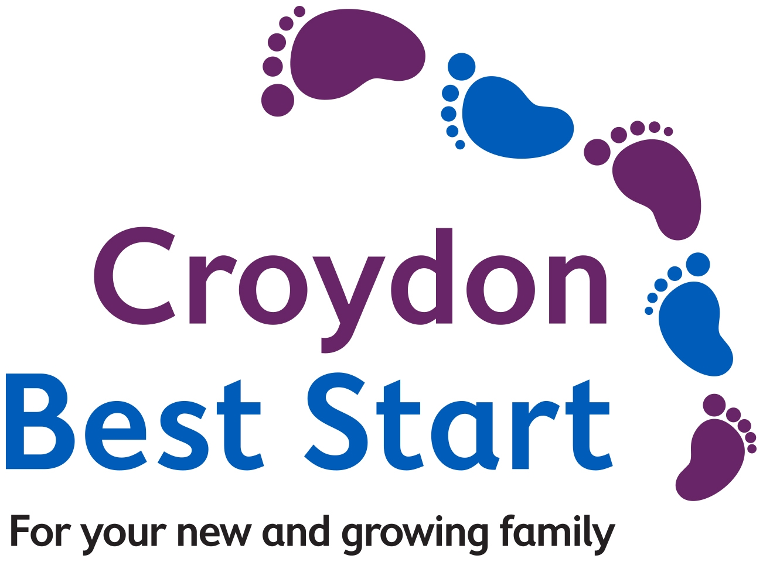

**Supporting children who**

**experience Social &**

**Communication Difficulties**

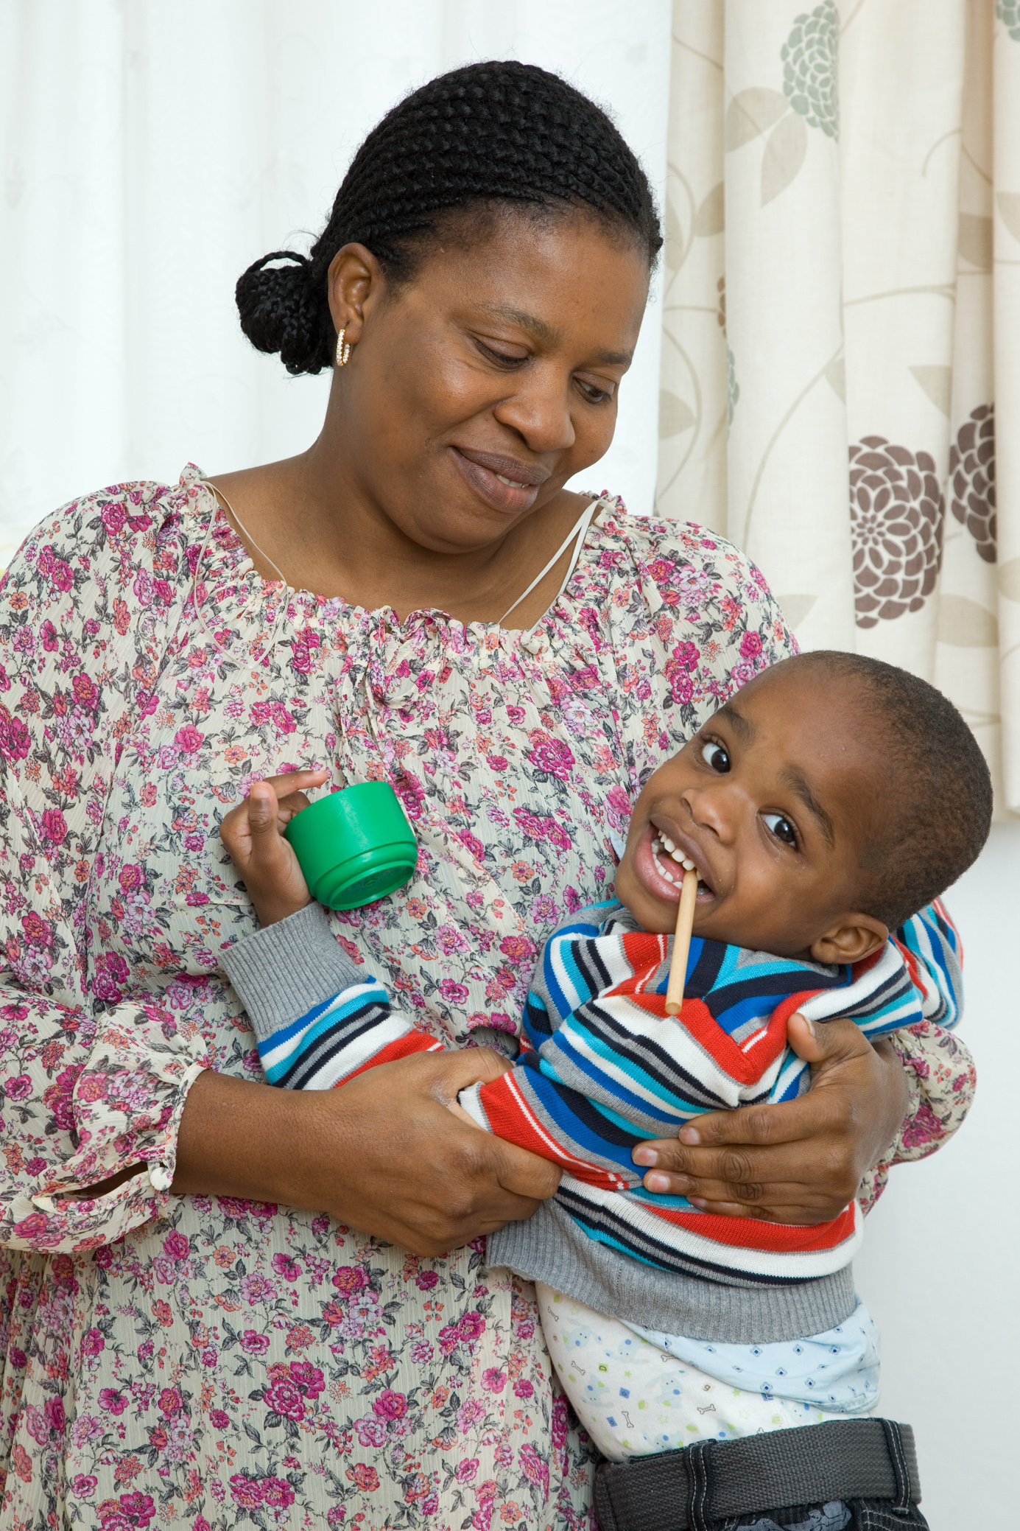

A course for parents & carers



 

**What do we offer?**

* An 8 week course (just one morning or afternoon per week) for families of children who experience Social & Communication Difficulties.
* Practical advice and strategies.
* Links to other supportive services in the borough.
* Encouragement and support from other families in similar situations.

|  |  |
| --- | --- |
| **Sessions** | **Aims** |
| **What children really need** | The first session is an introductory session. This focuses on - getting to know you and your child, understanding your hopes and expectations from the course, tips and strategies on looking after yourself. |
| **Communication** | Session two is based around communication. This is an interactive session and helps parents/carers to better understand ‘What is communication and ‘How can we encourage communication? |
| **Visual Supports** | In session three we will explore Visual Supports and How they work. You can also make a visual support to take home. |
| **Understanding Behaviour** | The fourth session helps parents/carers to understand the different types of behaviour your child may express (some of which may be challenging) and reasons why these behaviours might happen. We will also focus on anxiety, communication & sensory needs. |
| **Managing Behaviour** | Session five looks at Behaviour principles and gives parents/ carers practical strategies & tips for when your child is in the midst of a meltdown. |
| **Sensory Differences** | The sixth session explores how our human senses are experienced differently by a child with Social & Communication Difficulties; we will also talk about practical strategies and cost effective aids that may help |
| **Parents’ choice** | Session 7 will cover issues the group choose to explore further, to be confirmed as agreed by yourself and others in the group.  It may be around feeding, toileting, sleep etc… |
| **Transition** | The final session will be focusing on  ‘How to support your child’s transition’,  Your child may be moving on to Nursery or School in the near future and this session will give parent carers information tips on how to help the transitions move smoothly. |

# **What other parents say…**

# **How to get in touch**

This course is part of the Social Communication Difficulties Support Pathway offered by the Early Years SEN and Disabilities Team. If you are interested in attending the course and receiving support from the team, or for an informal chat about this course, please contact the course facilitator – Alex Dimond at croydonscd@nas.org.uk

cid:image003.jpg@01D1E97D.6334BF00

"I never used to understand but since this class, I've given him the opportunity to choose. He's at the cupboard pointing, and he's less anxious."

“It’s working! His behaviour has improved!”

“Visuals worked like magic!”

“It’s not me. I used to think I was doing something to cause this. Hearing other people tell my story has been life changing!”

In Partnership With